Save our Bus Service - Newsletter 2 Oct 2019

Background: Suffolk County Council has decided to withdraw the subsidy it provides to our local bus service, the 112. It currently runs only twice a week from our village to Sudbury, on Tuesday and Thursday, returning from the bus station at 13.10. Some people depend on it. The effect of this decision would be to withdraw the service altogether and increase hardship and isolation, when the County could be looking at increasing its attractiveness, frequency and usage.
The current situation: Suffolk County Council plans to withdraw the subsidy from the end of the financial year, so the service is only ‘safe’ until the end of March. The Cabinet member for Highways, Transport and Rural Affairs says if all those who objected used the service, it would be safe.

Here is the current timetable for Tuesdays and Thursdays. The bus stops at intermediate points on request.
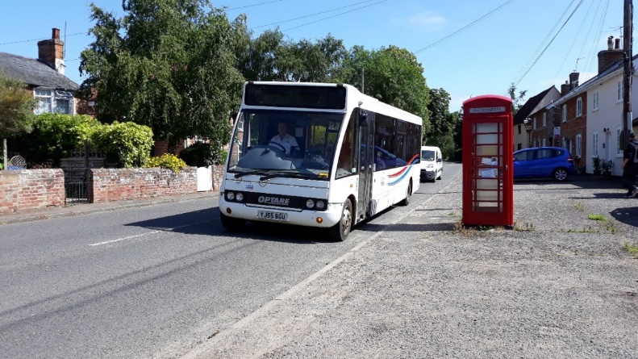 | Locations | Times
 | Hadleigh Bus Station | 09.30
 | Kersey, the Bell | 09.40
 | Semer Bridge | 09.45
 | Bildeston, Clock Tower | 09.50
 | Chelsworth, Peacock | 09.57
 | Monks Eleigh, Swan | 10.00
 | Brent Eleigh, Milden Rd | 10.03
 | Little Waldingfield, Swan | 10.10
 | Great Waldingfield, PO | 10.15
 | Sudbury Bus Station (A) | 10.25

Can you help us save our bus service?

What you could do:
- We need to try to be imaginative. Can you find ways of occasionally using the service? For people in full time work, this would be difficult. Otherwise, for young and old and all in between, there are reasons for which you could consider using the service. Could you sometimes use it to do errands in Sudbury, go to appointments, meet friends, visit the Kingfisher leisure pool and centre, visit the heritage centre at the Town Hall, visit the library, visit Belle Vue Park, younger folk maybe use its skateboard park during school holidays? Could you use it in one direction and find other means for the return journey if the times aren’t ideal?
- write to or email our MP, James Cartlidge MP, House of Commons, London SW1A 0AA, or james.cartlidge.mp@parliament.uk
- write to or email Mary Evans, Suffolk County Council Cabinet Member Highways, Transport and Rural Affairs, Endeavour House, 8 Russell Road, Ipswich IP1 2BX or mary.evans@suffolk.gov.uk
- write to or email the East Anglian Daily Times or the Suffolk Free Press

Please help
Save Our Bus Service

