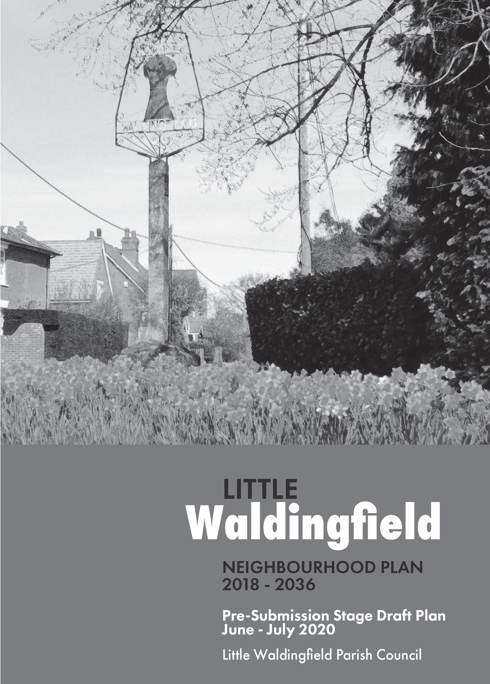
Neighbourhood Plan Consultation
Little Waldingfield Neighbourhood Plan
The Parish Council is pleased to be able to enclose a copy of the Draft Neighbourhood Plan for your consideration and comment.
What is a Neighbourhood Plan?
It is a new kind of planning document designed to allow local people to play an active part in planning their area. It can guide the development and conservation of Little Waldingfield and, for example, also identify proposals for:
- Improving areas;
- Providing new facilities;
- Sites for new development;
- Protecting sites of environmental or historic quality.
When complete, it will form part of the statutory development plan and both Babergh District Council and Planning Inspectors will have to take note of what it says when considering development proposals.
Consultation
This consultation runs from on or before 5 June 2020 until Friday 24 July 2020.
We cannot receive comments after this date.

Online Drop-in - Thursday 11 June 5.00pm to 6.00pm
If you have questions about the Plan, the Steering Committee are hosting a “Zoom” online drop-in event. Please feel free to log on anytime between 5.00pm to 6.00pm and one of the Committee will be available to answer your questions. You don’t have to stay for the hour, just log on when you are free. You can join the Drop-in event by clicking on this link https://us02web.zoom.us/j/81301458856 You do not have to download software and can join by clicking on “join from your browser”.
How to comment
Given the current restrictions we would prefer to receive your comments online by following the link to the Neighbourhood Plan section of the Village website, where you can view a copy of the Plan and complete an online version of the consultation response form: http://littlewaldingfield.onesuffolk.net/neighbourhood-plan/.
If you do not have online access, however, please use this consultation response form and the envelope provided. Instructions for its return are set out overleaf.
What next?
Following completion of this consultation, all comments received will be considered and any necessary amendments to the Plan will be made before the Parish Council submits the Plan to Babergh District Council. At that stage there will be further consultation followed by an independent examination of the Plan. This will then be followed by a Parish Referendum to decide whether the Neighbourhood Plan should be approved.

A lot of work has gone into the Plan so far. Please let us have your comments by 24 July 2020.

PRE-SUBMISSION CONSULTATION RESPONSE FORM
This form should be completed in conjunction with the draft of the Neighbourhood Plan – June 2020.
We would prefer receiving responses via the online feedback form during the pandemic to avoid any risk of contamination and this will also make the task of collating views much easier. However, if this is not possible then please complete this form. Further copies are available from:
  - The Neighbourhood Plan pages of the Parish Council website http://littlewaldingfield.onesuffolk.net/neighbourhood-plan/.
  - A box outside Barbara Campbell’s at Appeleton House, Church Road.

If you can’t complete the form online, you can submit your completed form in one of the following ways:
  - Email as an attachment to – barbaracampbell56@hotmail.co.uk.
  - Drop off at the collection box at Barbara Campbell’s at Appeleton House, Church Road.

If you have mobility issues and are unable to drop it off, please phone Barbara Campbell on 01787 249941 and we’ll arrange to collect it while respecting current social distancing requirements.
Please ensure your response is received by Friday 24 July 2020

NAME
ADDRESS (optional)
ORGANISATION / CLIENT YOU’RE
REPRESENTING (Where applicable)
EMAIL (optional)
Would you like to be notified when the Parish Council submits the Plan  to Babergh District Council? (if yes, please provide either address or email address) |  | Yes |  |  | No
Data Protection Notice: All information collected and processed by the Parish Councils at this stage is by virtue of our requirement
under the Neighbourhood Planning (General) Regulations 2012 (as amended).
Please note: All comments received will be made publicly available and may be identifiable by name / organisation. All other personal information provided will be protected in accordance with the Data Protection Act 2018.
CONSULTATION RESPONSE
Please continue on a separate sheet if the box isn’t big enough
1. Do you support the content of Sections 1, 2 and 3? |  |  | YES / NO / No opinion
Comments (please specify chapter and paragraph number)

2. Do you support the Vision and Objectives in Section 4? | YES / NO / No opinion
Comments (please specify the Topic and Objective number if appropriate)
3. Do you support Policy LWD 1 – Spatial Strategy? | YES / NO / No opinion
If No, please state what changes you would like
4. Section 5. Planning Strategy - Not including Policy LWD 1, do you support Section 5? | YES / NO / No opinion
Comments (please specify paragraph number)

5. Do you support Policy LWD 2 – Housing Development? | YES / NO / No opinion
If No, please state what changes you would like
6. Do you support Policy LWD 3 – Housing Allocations? | YES / NO / No opinion
If No, please state what changes you would like
7. Do you support Policy LWD 4 – Affordable Housing on Rural Exception Sites? | YES / NO / No opinion
If No, please state what changes you would like

8. Do you support Policy LWD 5 – Measures for New Housing Development | YES / NO / No opinion
If No, please state what changes you would like
9. Do you support Policy LWD 6 – Housing Mix | YES / NO / No opinion
If No, please state what changes you would like
10. Section 6 - Housing. Other than Policies LWD 2 to LWD 6 do you support the remaining contents of Section 6? | YES / NO / No opinion
Comments (please specify paragraph number)

11. Do you support Policy LWD 7 – Special Landscape Area? | YES / NO / No opinion
If No, please state what changes you would like
12. Do you support Policy LWD 8 – Dark Skies? | YES / NO / No opinion
If No, please state what changes you would like
13. Do you support Policy LWD 9 – Local Green Spaces? | YES / NO / No opinion
If No, please state what changes you would like

14. Do you support Policy LWD 10 – Protection of Important Views? | YES / NO / No opinion
If No, please state what changes you would like
15. Do you support Policy LWD 11 – Biodiversity? | YES / NO / No opinion
If No, please state what changes you would like
16. Section 7 – Natural Environment. Other than Policies LWD 7 to LWD 11 do you support the remaining contents of Section 7? | YES / NO / No opinion
Comments (please specify paragraph number)

17. Do you support Policy LWD 12 – Buildings of Local Significance? | YES / NO / No opinion
If No, please state what changes you would like
18. Do you support Policy LWD 13 – Heritage Assets? | YES / NO / No opinion
If No, please state what changes you would like
19. Do you support Policy LWD 14 – Holbrook Park Special Character Area? | YES / NO / No opinion
If No, please state what changes you would like

20. Section 8 – Historic Environment. Other than Policies LWD 12 to LWD 14 do you support the remaining contents of Section 8? | YES / NO / No opinion
Comments (please specify paragraph number)
21. Do you support Policy LWD 15 – Design Considerations? | YES / NO / No opinion
If No, please state what changes you would like
22. Do you support Policy LWD 16 – Sustainable Building? | YES / NO / No opinion
If No, please state what changes you would like

23. Do you support Policy LWD 17 – Flooding and Sustainable Drainage? | YES / NO / No opinion
If No, please state what changes you would like
24. Section 9 – Development Design. Other than Policies LWD 15 to LWD 17 do you support the remaining contents of Section 9? | YES / NO / No opinion
Comments (please specify paragraph number)
25. Do you support Policy LWD 18 – Protecting Existing Services and Facilities? | YES / NO / No opinion
If No, please state what changes you would like

26. Do you support Policy LWD 19 – Open Space, Sport and Recreation Facilities? | YES / NO / No opinion
If No, please state what changes you would like
27. Section 10 – Services and Facilities. Other than Policies LWD 18 and LWD 19 do you support the remaining contents of Section 10? | YES / NO / No opinion
Comments (please specify paragraph number)
28. Do you support the contents of the Policies Map, including the Village Centre Inset Map? | YES / NO / No opinion
If No, please state what changes you would like

29. Appendices. Do you have any comments on the Appendices? | YES / NO / No opinion
(Please state which appendix)
30. Do you have any other comments on the Draft Neighbourhood Plan? | YES / NO
Comments

Thank you for providing your feedback. We will take your comments into account in deciding whether amendments are required to the Neighbourhood Plan.
A Consultation Report for the Neighbourhood Plan will be published when the Plan is submitted to Babergh District Council.

